**Assignment 1**

Sampling, Estimation and Simulation

**ALY 6050 Intro to Enterprise Analytics**

Instructor: Prof. Tamir Hegazy

**Northeastern University**



**College of Professional Studies, Northeastern University, Boston, MA 02215**

Created By: Jayesh kamat

Email id: [kamat.j@husky.neu.edu](mailto:kamat.j@husky.neu.edu)

**INTRODUCTION:**

Assignment 2 project deals with how to run simulations as well as be able to perform different simulation techniques. After completing simulation, next steps were to apply some statistical data analysis techniques and then analyze the result with some good findings to support the claim and visualizations.

We received data related 5 hospitals that includes information about emergency facilities and capabilities to hold victims during disaster situation.

**ANALYSIS:**

**Problem 1**:

5000 Random numbers are generated between 0 and 1 using **RUNIF()** function in R. This was later used for calculating the triangular probability using the command **rtriangle(r,20,300,80)** which consist of minimum, maximum and peak value. Later plotted the histogram to check how the distribution looks like using **Histogram()** method from Library(lattice).

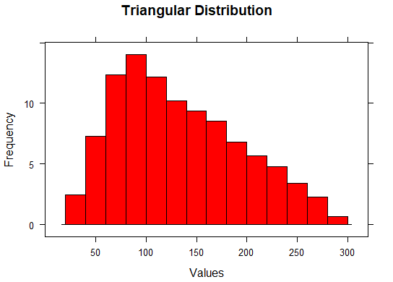

Created a function in R to calculate average victims my multiplying each value obtained in random values done by triangular probability with the respective percentage for allocation of disaster victims in each Hospitals. To calculate Average total time in hours for transporting all victims I again created a function in R, Function creation helps in reusability as for example, We can see below that with the help of one single function creation we are able to calculate the average time for all the hospitals.

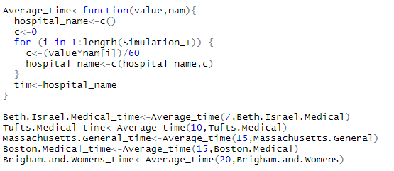

For the third part , to perform the law of large numbers first calculated the theoretical means of the victim allocation and the time taken for transportation to the hospital for Beth Israel Medical Hospital. Then created a loop to calculate the means of all the large numbers and later plotted the values which can be seen in the figure below:

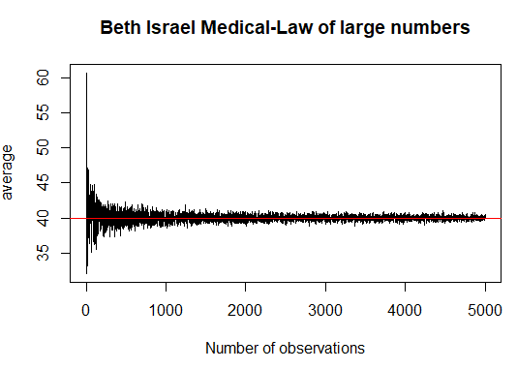

In the Fourth part, I performed data analysis for the total transport time by calculating the confidence interval of 95% .

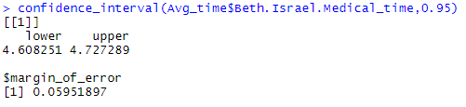

Then plotted the graph for it to see which probability distribution it fits by looking at the below graph we can say that the probability distribution that fits is Triangular probability distribution.

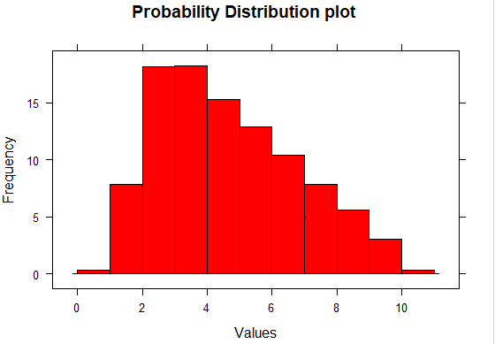

Then performed chi-square test to support the assertion and we can see that the p-value obtained is less than that of level of significance, so we can say we have a proof to our assertion that the data is triangular distribution.

|  |  |
| --- | --- |
| **Chi square Goodness of Fit Test** |  |
| **X-squared** | 24995000 |
| **Level of Significance** | 0.05 |
| **Df** | 24990001 |
| **p-value** | 0.2397 |
|  |  |
| **Null Hypothesis** | Triangular Distribution |
| **Alternate Hypothesis** | No Triangular Distribution |
|  |  |
| **p-value>level of significance** | Triangular Distribution |

For the Part five, I calculated the average transport time per victim in minutes by adding all the average time calculated for all hospitals in part two and dividing the overall solution by 60 to get the value in hours. Then calculated the confidence interval and plotted the histogram to see that triangular distribution.

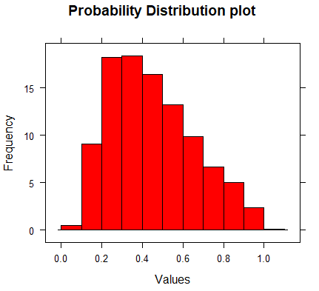

**Problem 2:**

5000 Random numbers are generated between 0 and 1 using **RUNIF()** function in R. This was later converted the data to be normally distributed using the command **rnorm(r,mean=150,sd=50)** which consist of mean and standard deviation value. Later plotted the histogram to check how the distribution looks like using **Histogram()** method from Library(lattice).

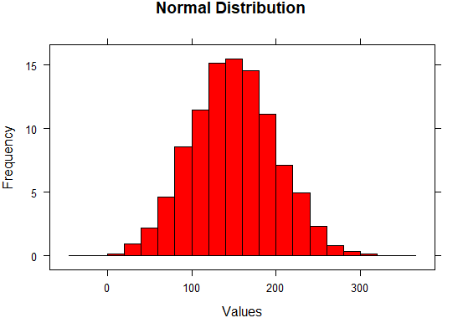

Created a function in R to calculate average victims my multiplying each value obtained in random values done by triangular probability with the respective percentage for allocation of disaster victims in each Hospitals. To calculate Average total time in hours for transporting all victims I again created a function in R, Function creation helps in reusability as for example, We can see below that with the help of one single function creation we are able to calculate the average time for all the hospitals.

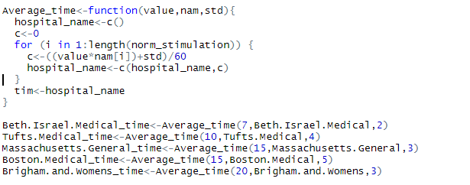

For the third part , to perform the law of large numbers first calculated the theoretical means of the victim allocation and the time taken for transportation to the hospital for Beth Israel Medical Hospital. Then created a loop to calculate the means of all the large numbers and later plotted the values which can be seen in the figure below:

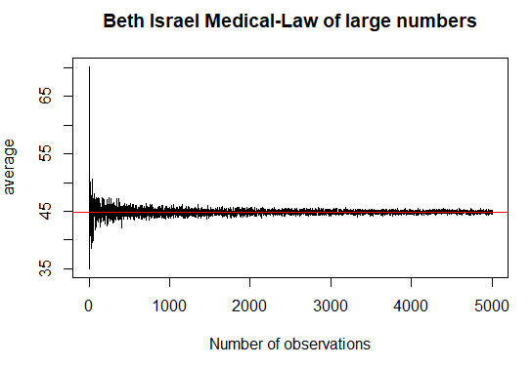

In the Fourth part, I performed data analysis for the total transport time by calculating the confidence interval of 95% .

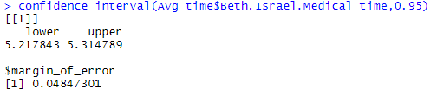

Then plotted the graph for it to see which probability distribution it fits by looking at the below graph we can say that the probability distribution that fits is Normal probability distribution.

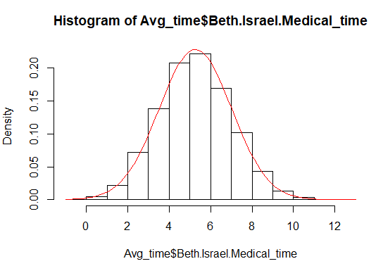

Then performed chi-square test to support the assertion and we can see that the p-value obtained is less than that of level of significance, so we can say we have a proof to our assertion that the data is Normal distribution.

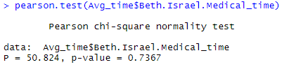

|  |  |
| --- | --- |
| **Pearson Chi-square Normality test** |  |
| **Level of Significance** | 0.05 |
| **p-value** | 0.7367 |
|  |  |
| **Null Hypothesis** | Data is Normally Distributed |
| **Alternate Hypothesis** | Data is not Normally Distributed |
|  |  |
| **p-value>level of significance** | Data is Normally Distributed |

For the Part five, I calculated the average transport time per victim in minutes by adding all the average time calculated for all hospitals in part two and dividing the overall solution by 60 to get the value in hours. Then calculated the confidence interval and plotted the histogram to see which distribution it supports:

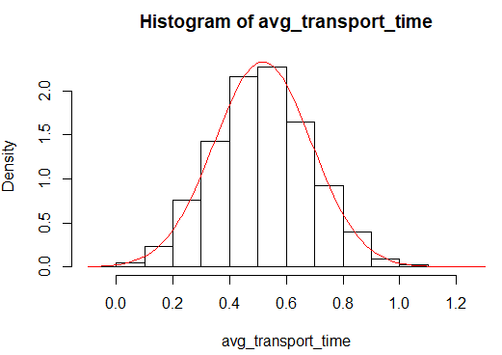

We can see that it data is normally distributed, by performing chi square test I received p-value less than the level of significance we can say that data is normally distributed.

|  |  |
| --- | --- |
| **Pearson Chi-square Normality test** |  |
| **Level of Significance** | 0.05 |
| **p-value** | 0.5681 |
|  |  |
| **Null Hypothesis** | Data is Normally Distributed |
| **Alternate Hypothesis** | Data is not Normally Distributed |
|  |  |
| **p-value>level of significance** | Data is Normally Distributed |

**CONCLUSION:**

In this Simulation operation is carried on using triangular and normal probability distribution it gives an idea to predict the allocation required by the hospitals in emergency to transfer victims to the hospitals.